How to find resources with [Katalog Plus](https://ubmr.hds.hebis.de/?lng=en)

# Starting Point

Go to [Katalog Plus](https://ubmr.hds.hebis.de/) on the University Library’s website. There, you find the search box. First of all, choose if you want to look for books or articles.

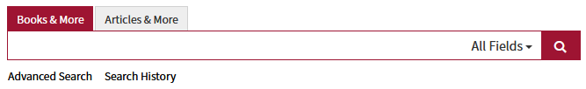

Example: Searching for „Introduction to Psychology”

result: list of more than 7000 titles

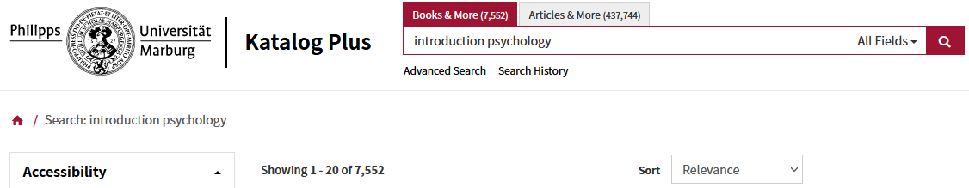

Further information from the list of results:

* What publication type is it? Printed or electronic?
* Is the item available for borrowing, for in-house use only

or is it checked-out?

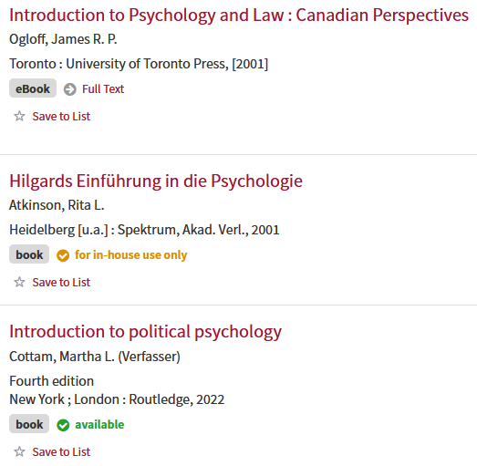

On the left-hand side, you find various categories that help you narrow down and specify your search.

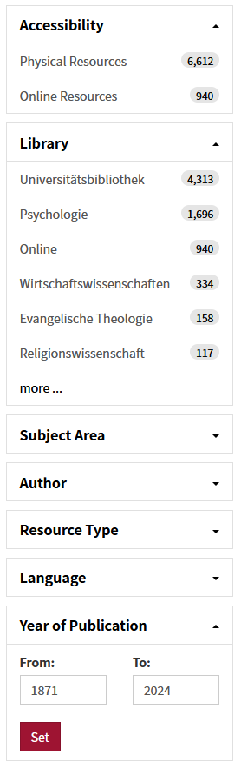

For more detailed information just click on a title. You are directed to the **full bibliographic record**, which consists of two sections: At the top of the page, you find bibliographic information on the medium and its content. At the bottom of the page, there is information on the location of the item and its availability.

# How to find books?

At the top of the catalogue entry, you find the **full bibliographic record** of the item including page number, edition and language. If you click on the links you get **additional information**.  
If you click on „**Author**“,  you find further publications by the same author.  
Often, there is a link giving you more information on the content of the publication or the **table of contents**, which enables you to check online whether the title is relevant for you.  
You can also use the **subject terms** or the **RVK-Notation** for your search. The RVK-Notation also gives you information on the content by showing you similar publications. You can also broaden your search by selecting subject terms.

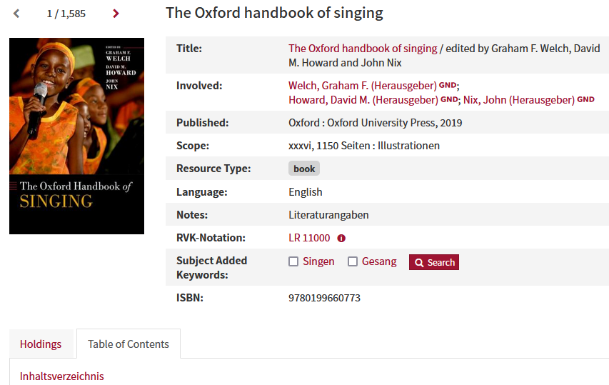

At the bottom of the entry, there is **information on the item** or items available at the Marburg University Library or at the branch libraries.

In our example:

* There is one copy in the University Library (Deutschhausstraße 9).
* The copy is only available for in-house use.

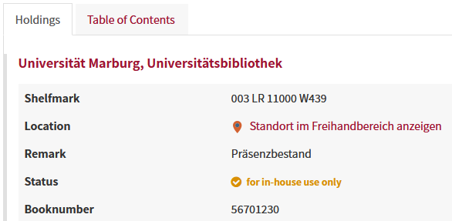

The **shelfmark** shows you, where to find the book in the library. In our case, it is in the Musicology section. The three digits at the beginning of the shelfmark indicate that you cannot borrow the book. (001/011: short-term loan, 003/013: for in-house use only (presentation))  
The books are arranged by classification categories, sorted by discipline. In our case **LR 11000**, and then according to the second code number.  
To make your search easier, click on the link to our virtual map (“Standort im Freihandbereich anzeigen”), which shows you the location of the book. In our example: third floor, shelf 3-0234.  
Please write down the author’s name, title, and shelfmark to find the correct book on the shelf.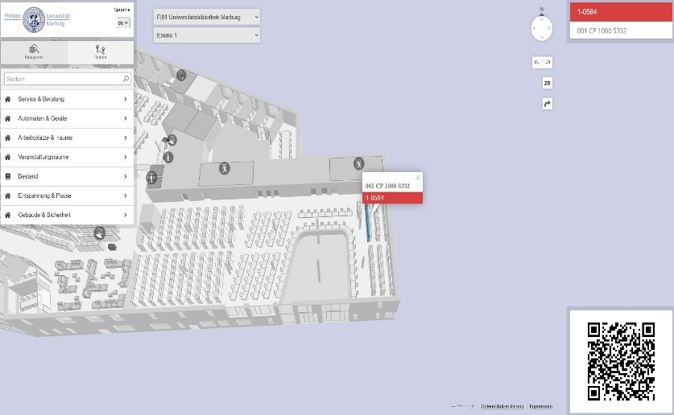

# How to find journals?

Tab „articles and more“

If you choose the tab „articles and more“, the list of results changes. You no longer see books but relevant articles and there are other categories you can use to narrow down or expand your search.

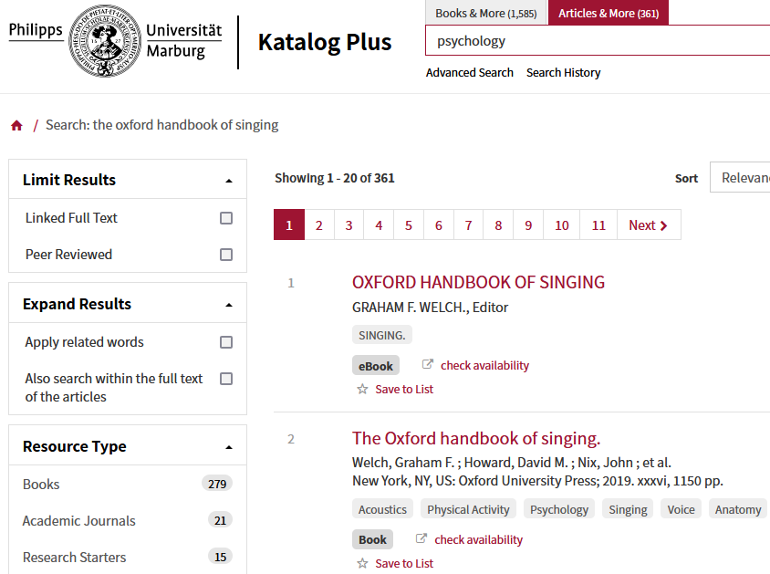

# Catalogue entries of journals

Entries for journals are similar to those of monographs. You get information on the publication history at the top of the page and on the University Library’s holdings at the bottom of the page.

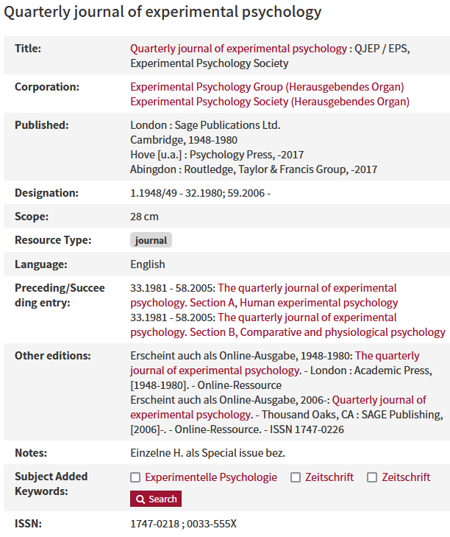

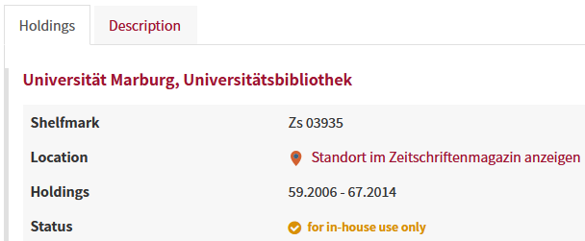

# Textbook collection

The textbook collection is on level -1 and it is arranged according to disciplines. Textbook shelfmarks start with 050 and have yellow stickers. You can borrow textbooks for four weeks.

# Open stacks and journal stacks

Not all books available in the University Library (Deutschhausstraße 9) are in the RVK-section that is arranged by discipline and subject. Some books are in the open stacks on level -1 (signatures beginning with "070"). In the open stacks – as well as in the journal stacks – books are arranged by format and year of purchase. In the open stacks and journal stacks, books are stored in compact shelves, which move along rails. Please familiarise yourself with the safety precautions before using them.